Endocrine System Worksheet

Fill in the gaps in the sentences below using the words in the list.

**target; blood; ducts; hormones**

1. Endocrine glands release their secretions directly into the blood. In other words, they have no ...................
2. Endocrine glands secrete chemicals called ....................
3. Hormones are transported from the endocrine glands to all parts of the body by the ..............................
4. Although hormones are carried throughout the body, they only affect specific ......................... organs and tissues
5. The position of endocrine organs has been indicated in red on the diagram of a composite male and female dog shown below. Add the labels in the list to the diagram.

**Ovary; Pancreas; Thyroid gland; Pituitary gland; Testis; Adrenal gland; Pineal gland; Parathyroid gland**

[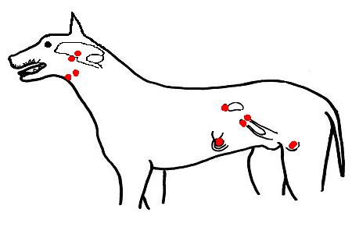](https://wikieducator.org/File:Endocrine_organs_of_dog.JPG)

1. On the diagram of the brain below, indicate the position of the **Hypothalamus** and **Pituitary gland.**[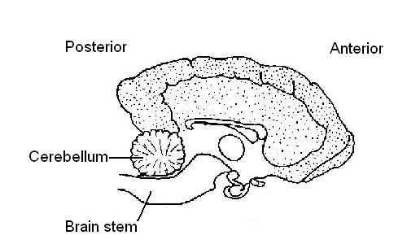](https://wikieducator.org/File:Dog%27s_brain_partially_labelled.JPG)
2. In the table below, list 3 hormones produced by the **pituitary gland** and state the function of each.

|  |  |
| --- | --- |
| **Hormone** | **Function** |
| 1............................ | ..................................................... |
| 2............................ | ..................................................... |
| 3............................ | ..................................................... |

1. Fill in the following table with the endocrine organ the hormones are produced by.

|  |  |
| --- | --- |
| **Hormone** | **Produced by:** |
| Insulin | ......................... |
| Progesterone | ......................... |
| Oestrogen | ......................... |
| Growth hormone | .......................... |
| Adrenaline | ........................... |
| Antidiuretic hormone | ........................... |
| Testosterone | ........................... |
| Aldosterone | ........................... |
| Melatonin | ............................ |
| Oxytocin | ............................ |
| Thyroxine | ........................... |

1. Match the hormones in the list below with their functions.

**Oxytocin; Insulin; Oestrogen; Growth hormone; Antidiuretic hormone; Testosterone; Adrenaline; Cortisone; Melatonin; Progesterone; Thyroxine; Luteinising hormone; Follicle stimulating hormone**

|  |  |
| --- | --- |
| **Hormone** | **Function** |
| ................................. | 1. Stimulates development of the ovarian follicle. |
| ............................... | 1. Stimulates milk “let down”. |
| ................................ | 1. Controls blood glucose levels. |
| ................................. | 1. Influences the rate of growth and development of young animals. |
| ............................... | 1. Stimulates the growth of long bones. |
| ............................... | 1. Stimulates absorption of water from the kidney tubule. |
| ............................... | 1. Influences the development of sexual maturity. |
| ................................ | 1. Stimulates the development of the corpus luteum. |
| ................................ | 1. Stimulates the development of female sexual characteristics. |
| ................................. | 1. Stimulates the development of the male sexual characteristics. |
| ................................. | 1. Affects glucose, protein and fat metabolism. |
| ................................. | 1. Prepares the lining of the uterus for pregnancy. |
| ................................. | 1. Prepares the body for emergency situations. |

1. Circle the odd one out.

1. melatonin; oxytocin; growth hormone; antidiuretic hormone; follicle stimulating hormone.

2. progesterone; oestrogen; luteinising hormone; cortisone; follicle stimulating.

3. adrenaline; cortisone; aldosterone, oestrogen, insulin.